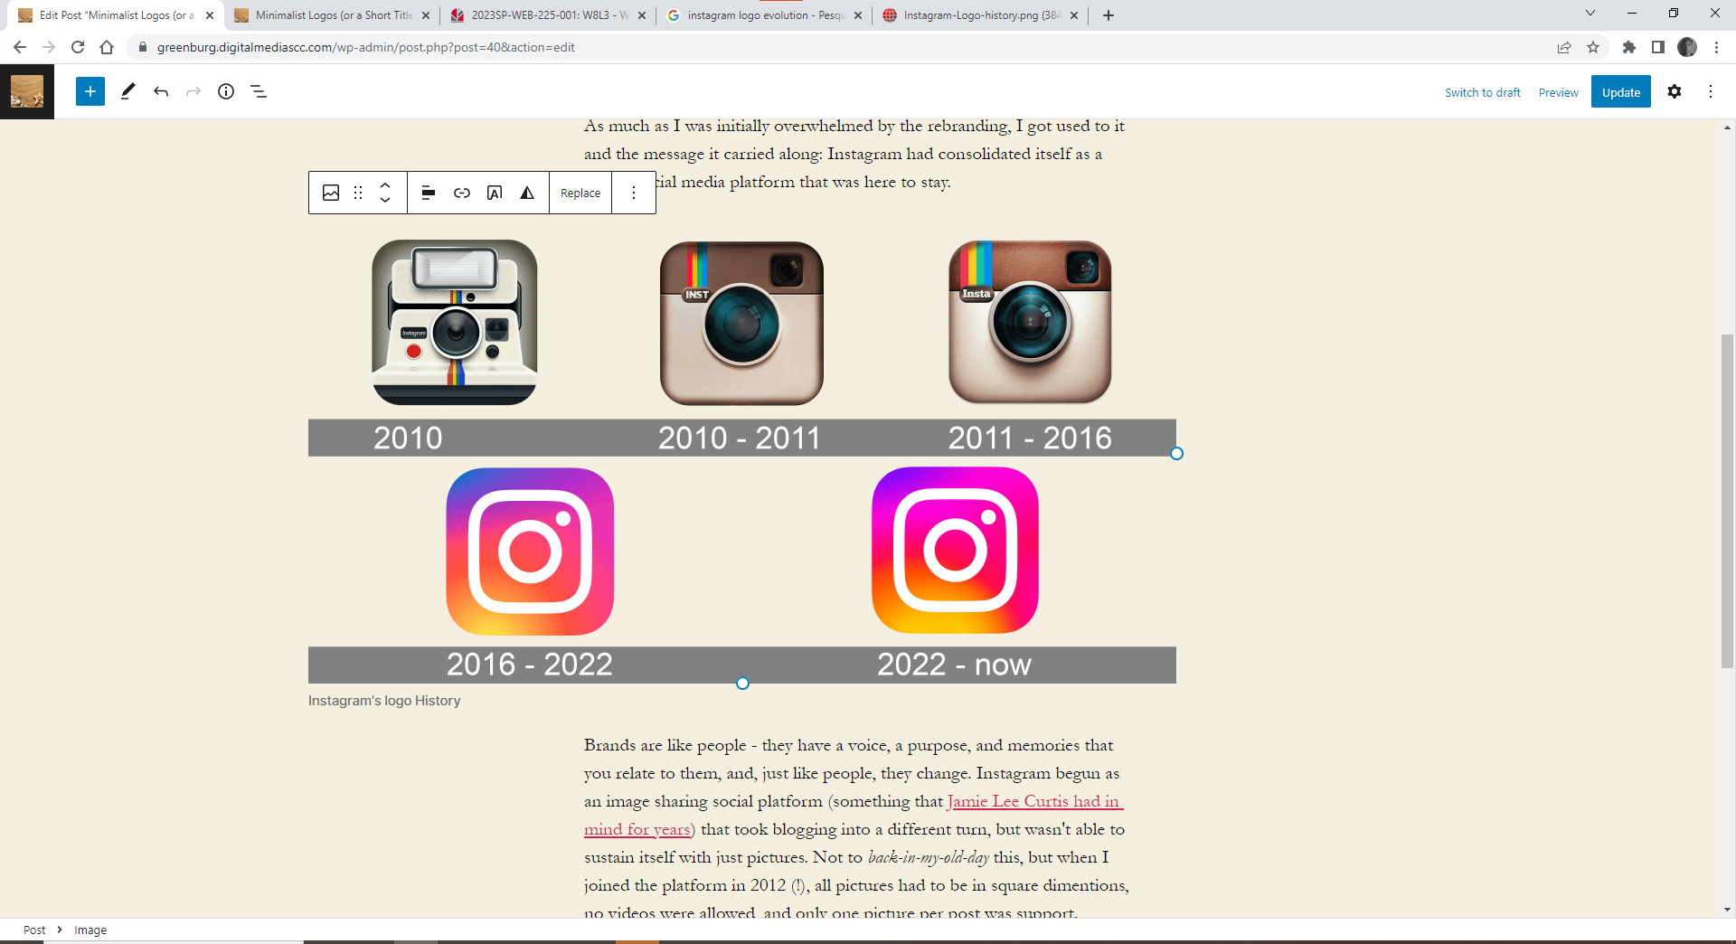

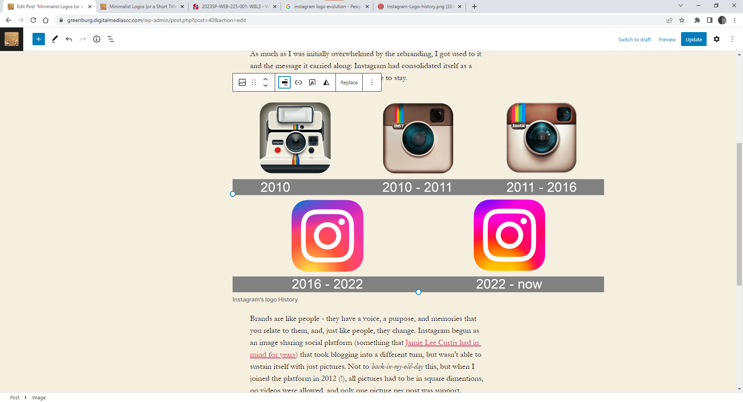
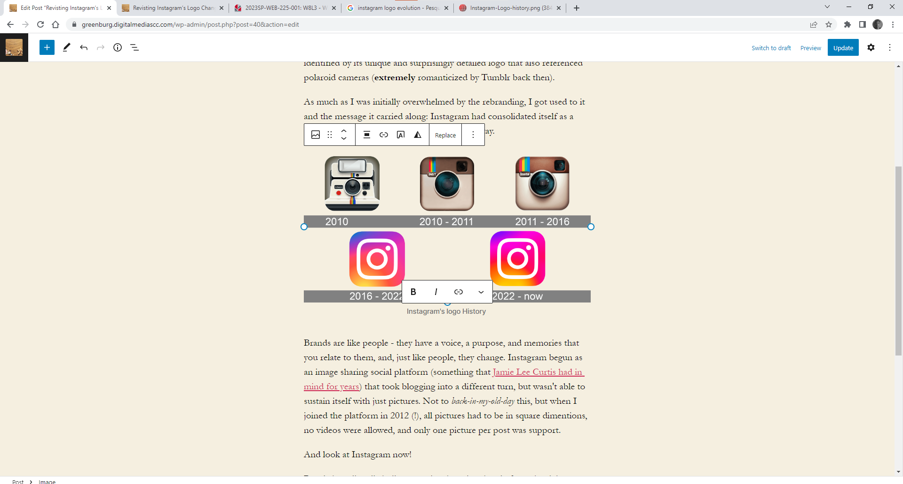

Full Width and and Wide Width

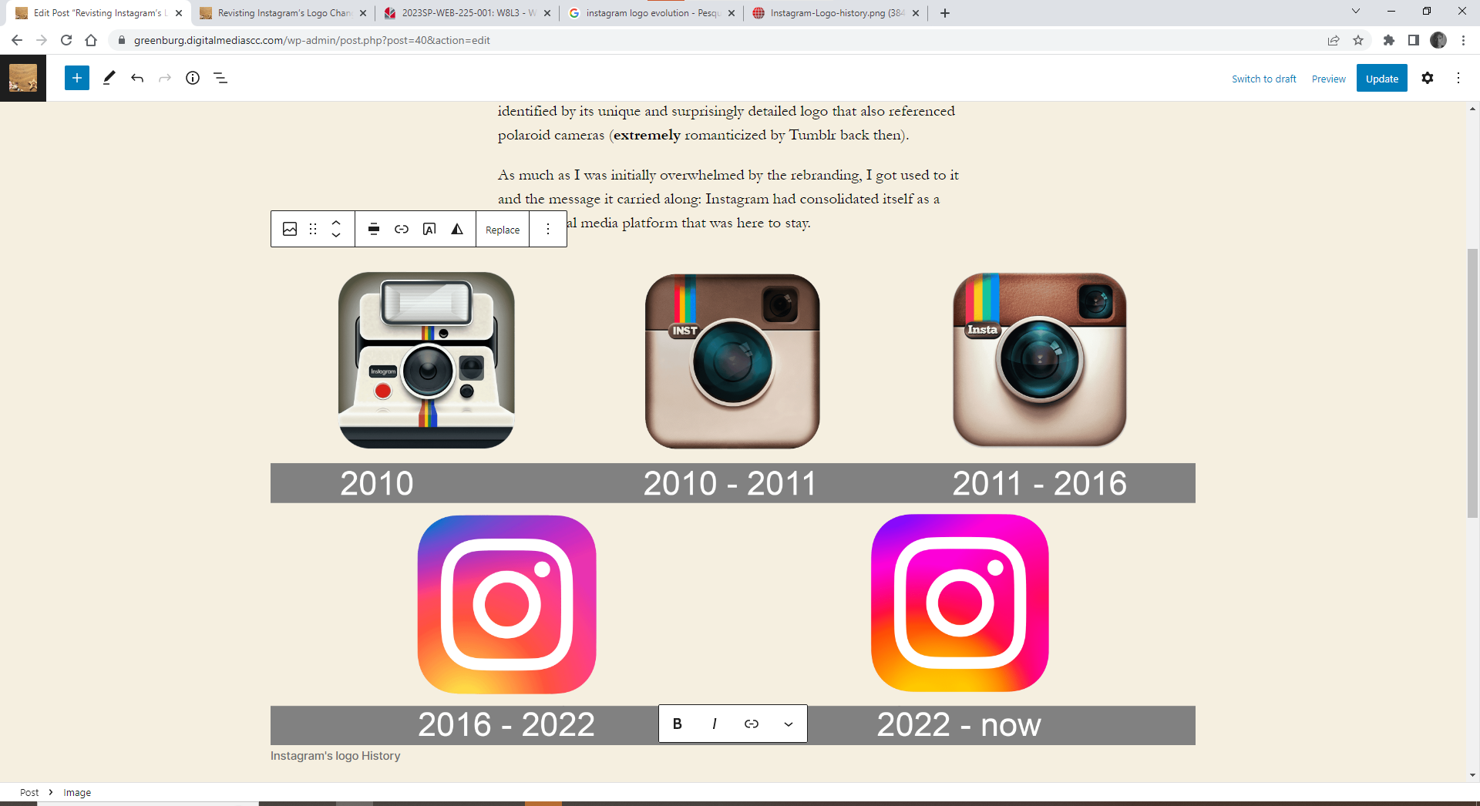

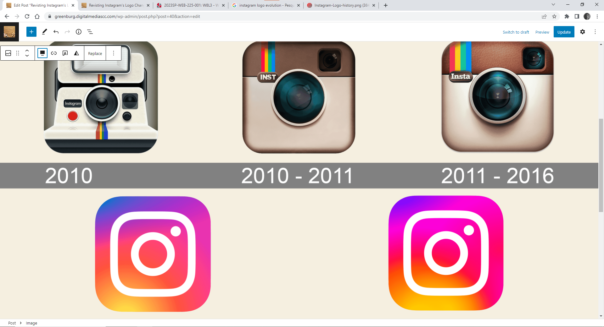
I found this link in the HTML code: https://greenburg.digitalmediascc.com/wp-content/uploads/2023/03/windows_logos-300x188.png (I set it up as medium size)
Image URL for the second post: https://greenburg.digitalmediascc.com/wp-content/uploads/2023/03/windows_logos.png

Media/Text block
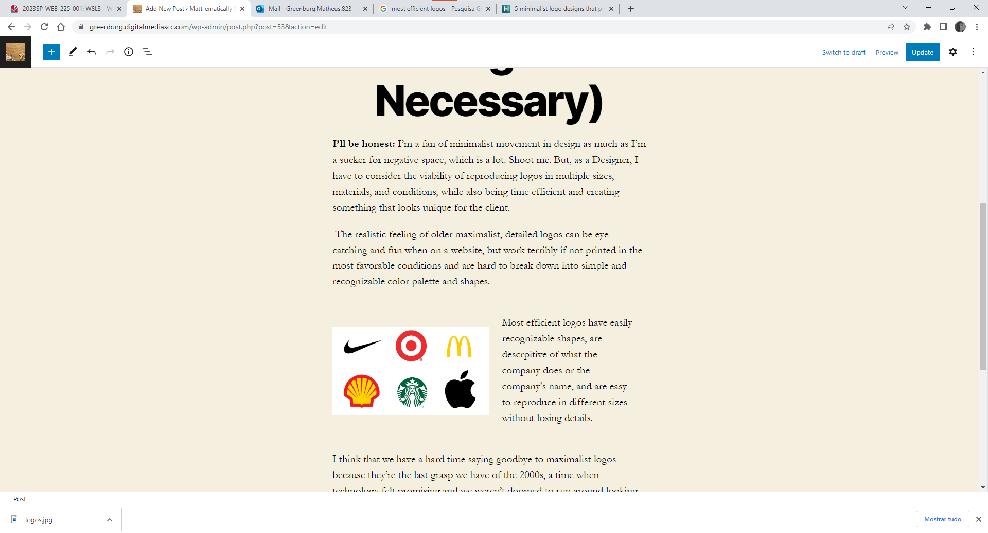
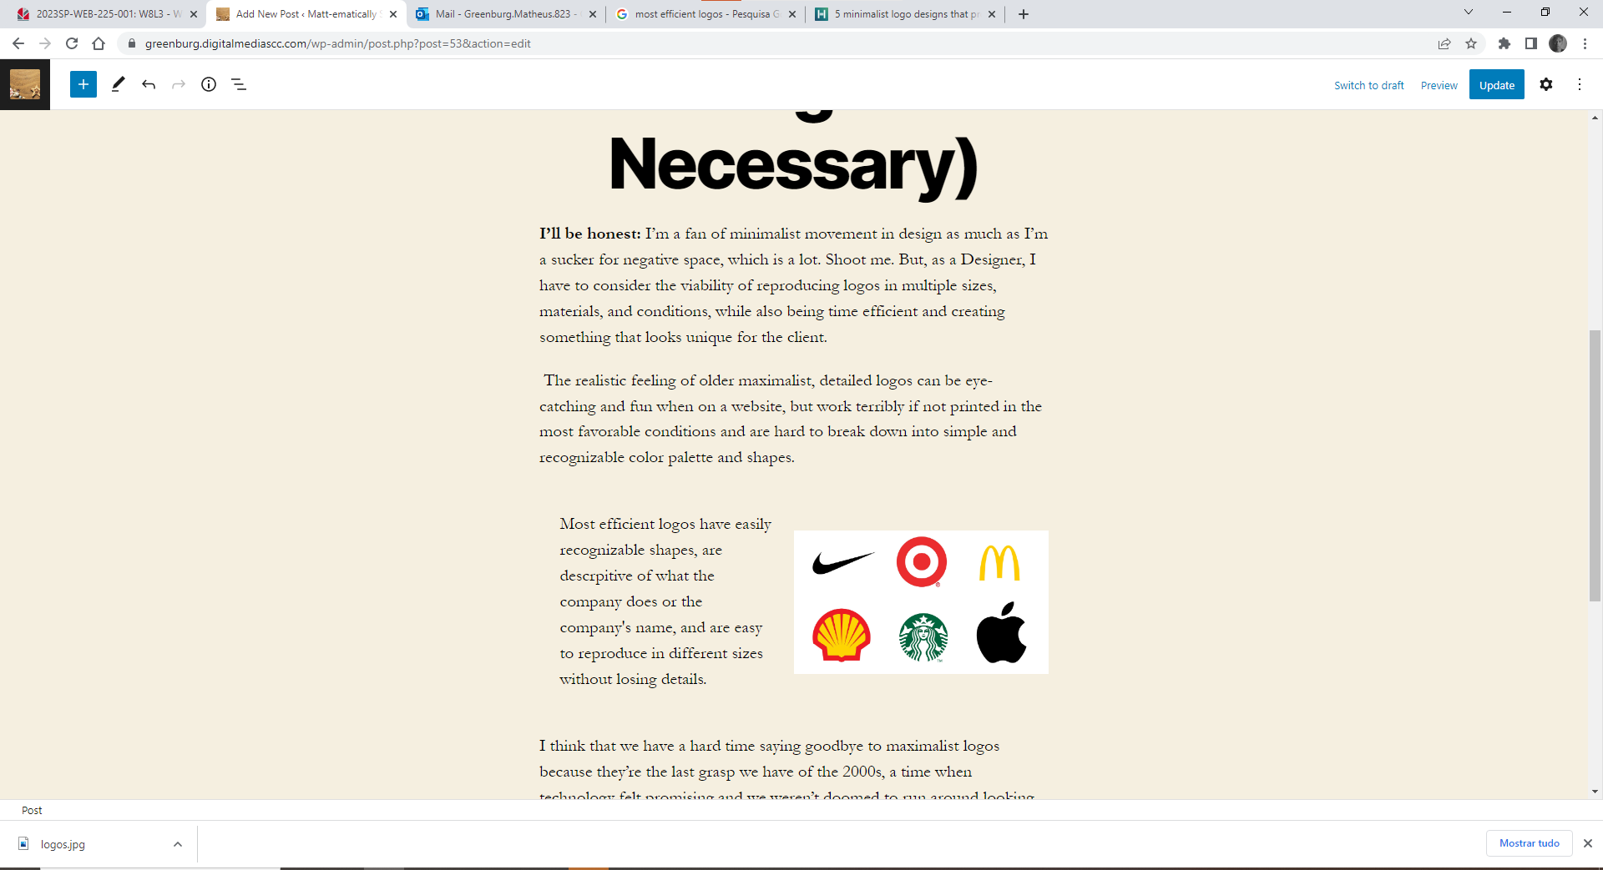
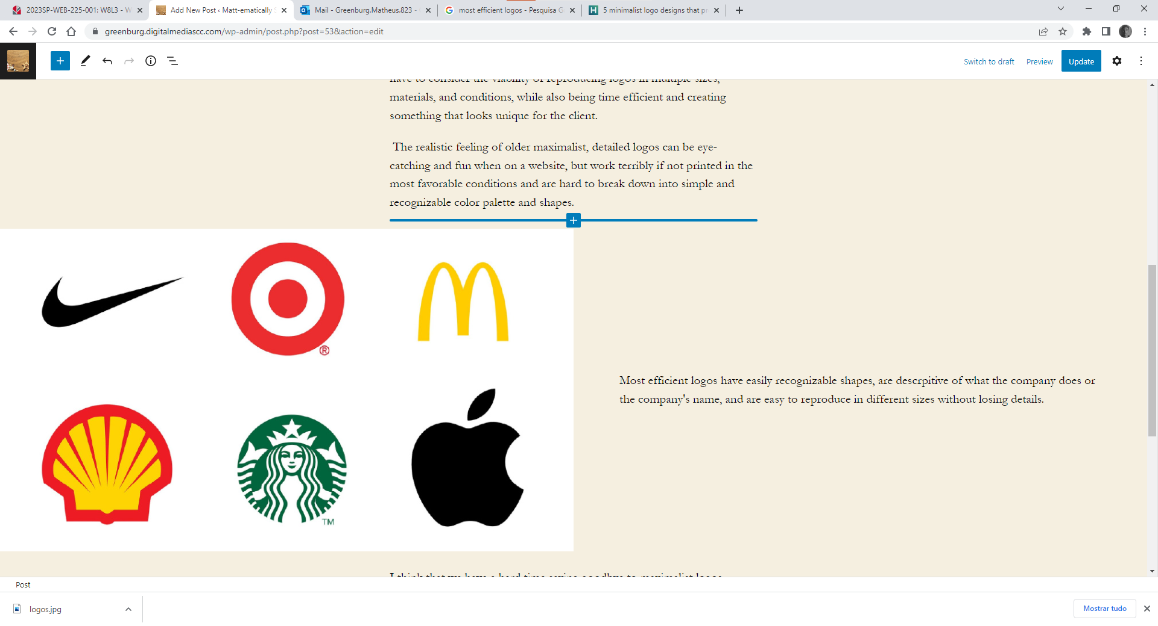
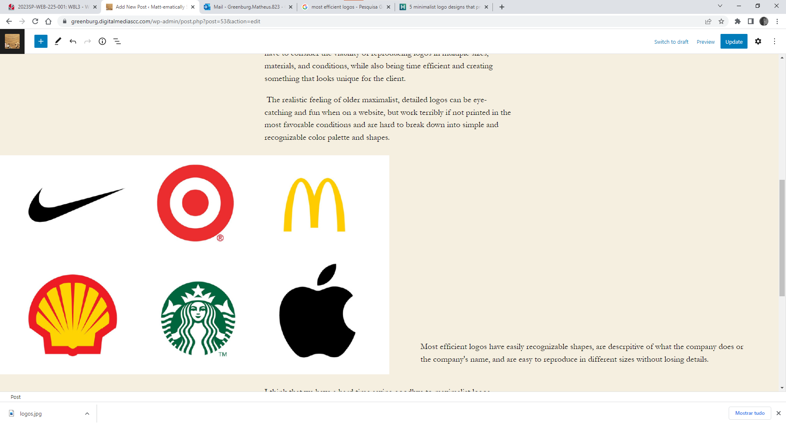
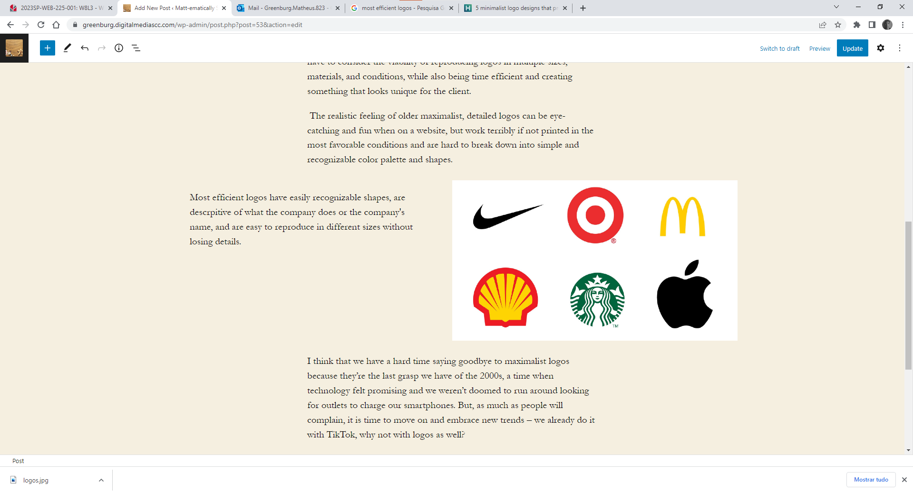
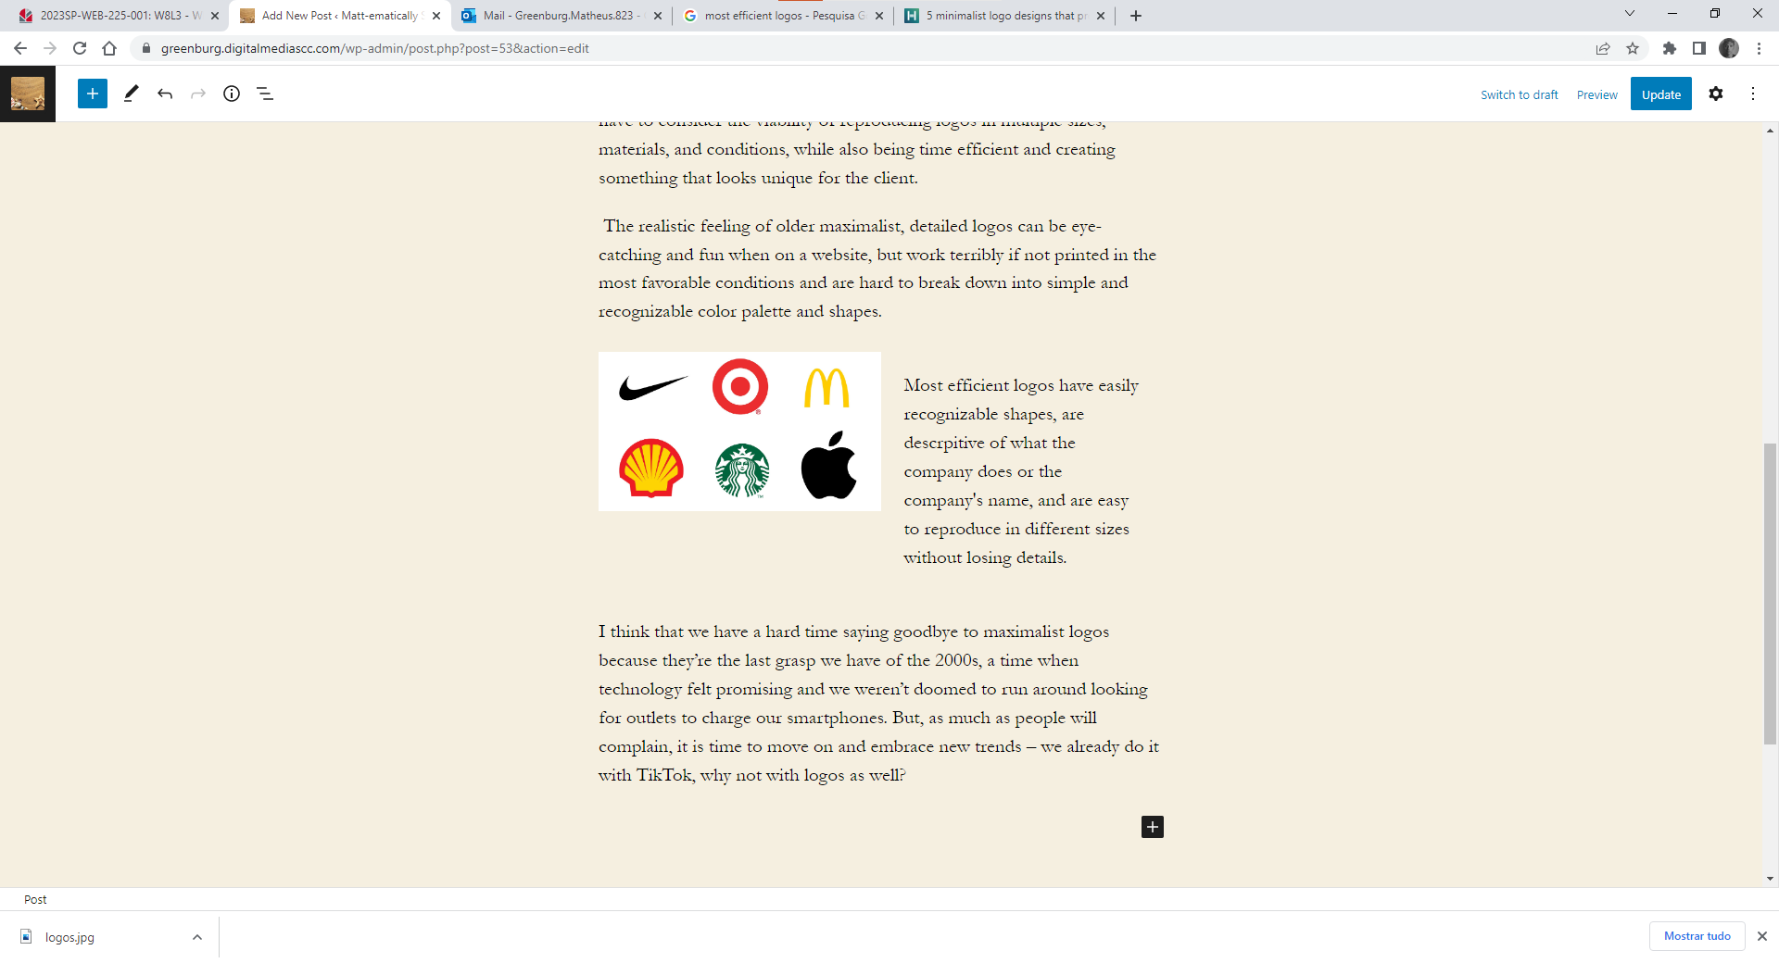
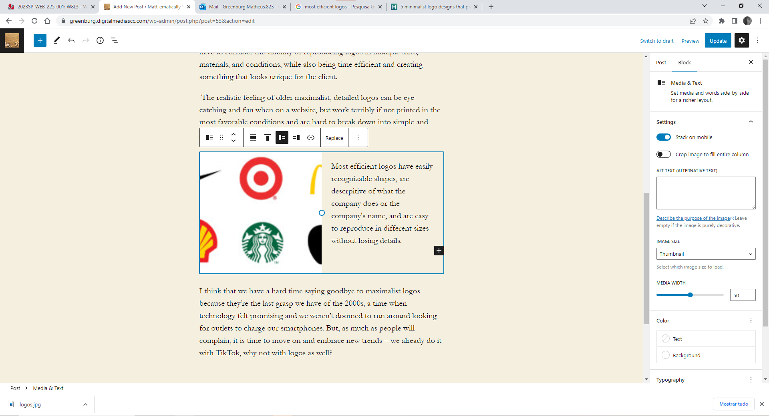
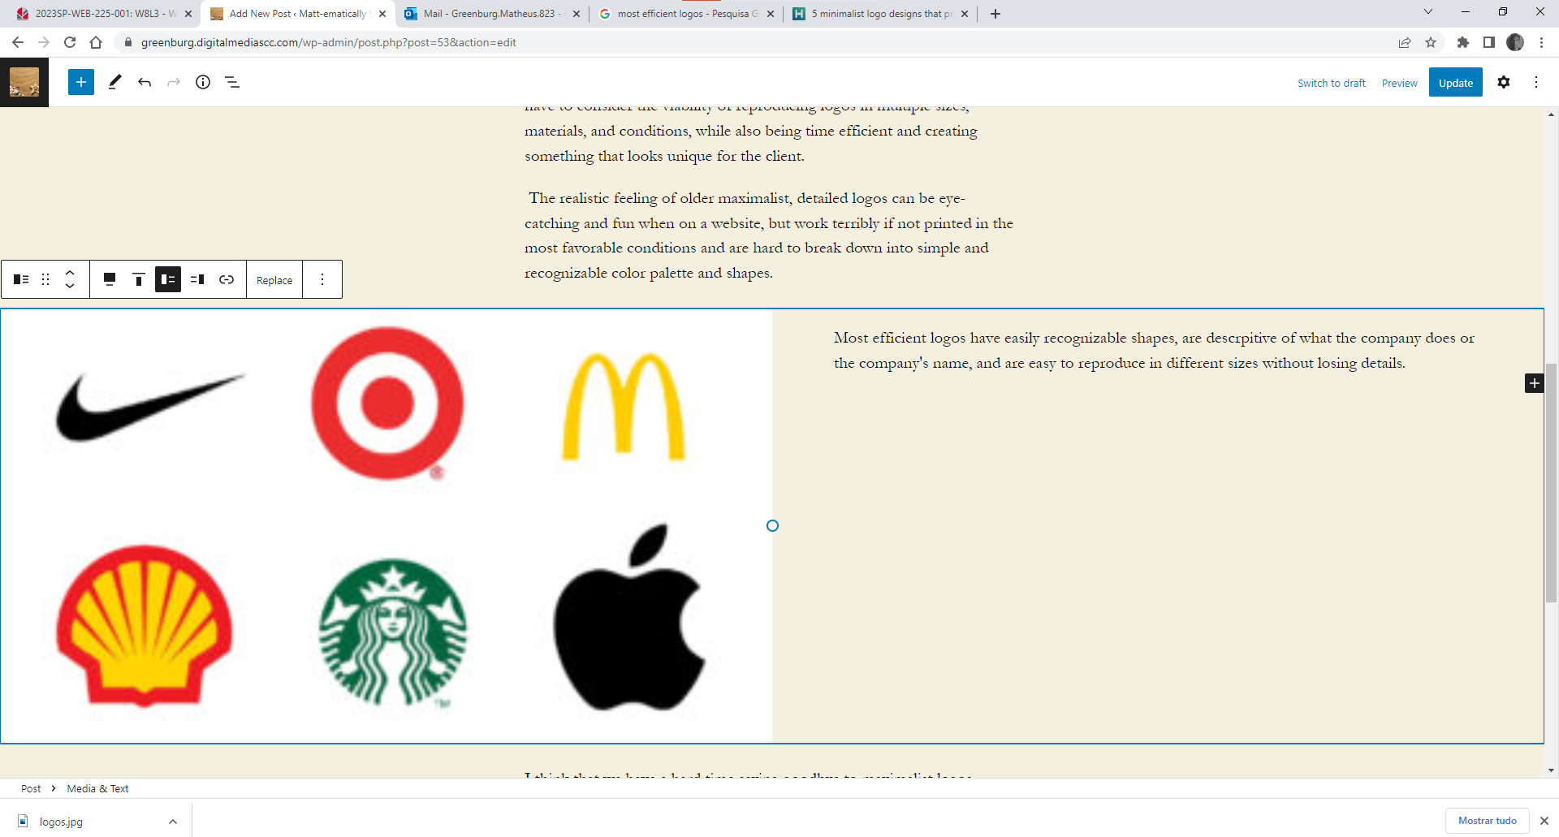
By using different image sizes, it seems that the resolution changes, but WordPress “stretches” the image out to still fill the width in the chosen settings.
I added a gallery to my last post (4th in this assignment). I’m not sure what the New Theme relates to – are we changing the whole Website Theme? Are we installing a gallery block? Those don’t have consistent customizable options. I ended up adding WordPress Gallery Block and an installed one. Each has a different layout for the caption – WordPress’ isn’t as legible.
I didn’t feel the need to change anything in the featured image.

